37T Log Splitter

To provide safe operation and prolong the service life of your product, we strongly suggest you read and understand the full contents of this user manual, and also the full engine manual which is included separately.
For technical queries or replacement parts, please contact us.

SPECIFICATIONS
Max. Pressure: 3000psi
Pressure Relief Setting: 3000psi
Maximum Hydraulic Flow: 22GPM
Hydraulic Cylinder Bore: 5”
Hydraulic Oil Grade: ISO32 or ISO46
Hydraulic Oil Capacity: 50L
Engine Oil Capacity: 1.1L (Petrol variant), 1.6L (Diesel variant)
Engine Oil Grade: 10w/30 (Recommended) Alternative grades also permitted – refer to engine handbook)

The manufacturer reserves the right to make improvements in design, and/or changes in specifications at any time without incurring any obligation to install them on units previously supplied.
Eye protection should be worn during operation, and when performing servicing and / or maintenance.

Trailer Connection
The trailers hitch coupler must be properly secured to the hitch ball of the towing vehicle. After assembly and attachment, pull up and down on the hitch coupler to ensure the hitch ball is a snug fit with the hitch coupler.
There must be no play between the hitch ball and the hitch coupler. If there is play, tighten the adjustment nut until no play is present. If the adjustment nut is too tight, the handle will not lock.
Ensure the safety chain is also securely the safety chain to the towing vehicle before towing.
Carefully read and follow the complete instructions in this manual before setup or use.
If the coupler is not secured properly, the ball could come loose while the trailer is in motion, possibly causing damage, injury or death.

Before Each Use
It is important to inspect and maintain the log splitter before each use.
If the log splitter has been used previously, it must be inspected and maintained before each subsequent use.
Always switch off the engine and relieve system pressure by moving the split control lever back and forth several times before inspecting, cleaning, adjusting or repairing the splitter.
If any part requires replacement, only use parts that meet the manufacturers specifications. Replacement parts that do not meet the correct specifications may result in a safety hazard or poor operation of the splitter.
Remove debris from moving parts - Debris on moving parts can cause excessive wear. Clear debris from the slide beam, cutting wedge and endplate.
Mechanical parts - Check all nuts and bolts are tight to ensure the splitter is in safe working condition.
Hydraulic Components - Check the hydraulic components carefully:
Visually inspect all hoses and fittings for cracks, fraying, kinks or other damage.
Check all components for oil residue, which may indicate a leak.
Do NOT operate the log splitter if there is any indication of damage or oil residue. Small leaks in hydraulic lines can cause severe injuries and can also be an indication of catastrophic failure in the near future. The life of hydraulic hoses may range from a few months to a few years, depending on use and storage patterns.
Warning!
High pressures and temperatures are developed in hydraulic log splitters. Hydraulic fluid escaping through a pin hole sized opening can burn or puncture skin, resulting in wounds that could cause blood poisoning, infection, disability, gangrene, amputation or death.
The following instructions therefore, should be heeded at all times when inspecting or servicing hydraulic components on the log splitter.
Stop the engine and relieve system pressure by moving the control handles back and forth several times before changing or adjusting hydraulic system components such as hoses, fittings or other components.
Never check for leaks with your hand – Leaks can be located using a piece of wood or cardboard at least 2ft/60cm long, with your hand at one end and passing the other end over the suspected area. Look for discolouration on the wood/cardboard.
If injured by escaping fluid, no matter how small the wound is, treat as a medical emergency and see a doctor at once. A typical injection injury may be a small puncture wound that does not look serious. However, severe infection or reaction can result if proper medical treatment is not administered immediately by a doctor who is familiar with injection injuries.
Shields / Guards - Replace all guards and shields after servicing the log splitter.

Work site and log splitter setup
Warning!
It is important to select an appropriate work site and properly set up the log splitter in order to minimise the risk of slips and falls, equipment rolling or tipping over, carbon monoxide poisoning, and accidental fires.
Select Location - Select a dry, level surface with good footing, outdoors away from air intakes. Stay clear of areas with mud, ice, tall grass, weeds, brush etc.
Warning!
A running engine produces carbon monoxide, a poisonous gas that can kill you. You can not smell it, see it or taste it. Only run the log splitter OUTDOORS and away from air intakes. NEVER run the log splitter inside homes, garages, sheds or other buildings or semi enclosed spaces. These spaces can trap poisonous gases, even if you run a fan or open windows.
If you start to feel sick, dizzy or weak while using the splitter, shut off the engine and get to fresh air right away. See a doctor – You may have carbon monoxide poisoning.
Fire Precautions - Take the following precautions against fire:
Keep a fire extinguisher available (classified for both ordinary combustibles & flammable liquids) as a precautionary measure when operating the log splitter.
Position the exhaust and other hot elements at least 7ft / 2.5m from combustible objects during splitter operation. Hot exhaust gasses from the engine could cause fire.

Engine Starting and Operation
Please note: This engine information is a guide only; for full safety, maintenance and operator information, refer to the separate engine manual included with your log splitter.
PLEASE NOTE – THE SPLIT CONTROL LEVER MUST BE IN THE NEUTRAL (N) POSITION BEFORE ATTEMPTING TO START THE ENGINE. This is to prevent any unexpected movement of the ram, and also to reduce initial start-up strain on the engine, which could otherwise cause difficulties in starting the engine.
The engines are designed to give safe and dependable service if operated according to instructions. Read and understand the separate owner’s manual before operating the engine. Failure to do so could result in personal injury or equipment damage. Know how to stop the engine quickly, and understand the operation of all controls. Never permit anyone to operate the engine without proper instructions. Do not allow children to operate the engine. Keep children and pets away from the area of operation.
Refuel with Care - Petrol is extremely flammable, and petrol vapor can explode. Refuel outdoors, in a well-ventilated area, with the engine stopped. Never smoke near petrol, and keep other flames and sparks away. Always store petrol in an approved container. If any fuel is spilled, make sure the area is dry before starting the engine. Hot Exhaust: The muffler becomes very hot during operation and remains hot for a while after stopping the engine. Be careful not to touch the muffler while it is hot. Let the engine cool before storing it indoors. To prevent fire hazards and to provide adequate ventilation for stationary equipment applications, keep the engine at least 3 feet (1 meter) away from building walls and other equipment during operation. Do not place flammable objects close to the engine. Carbon Monoxide Hazard: Exhaust gas contains poisonous carbon monoxide. Avoid inhalation of exhaust gas. Never run the engine in a closed garage or confined area.

4-STROKE LONCIN G420 PETROL VARIANT:
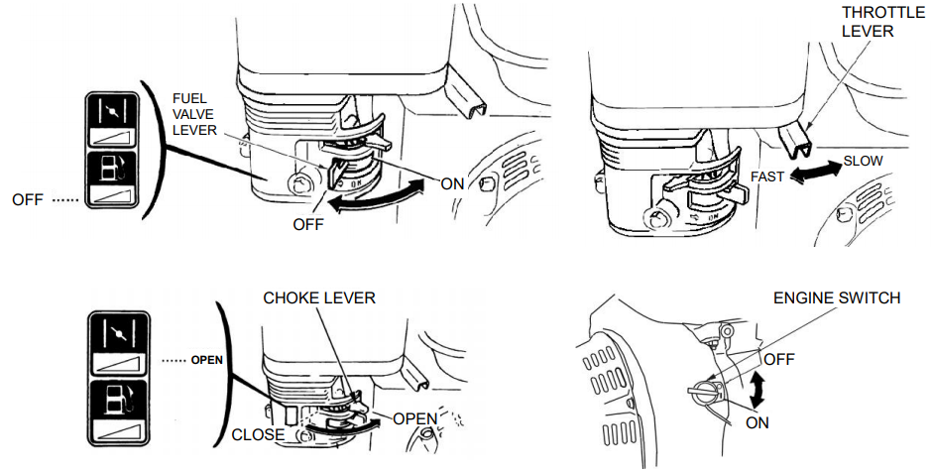
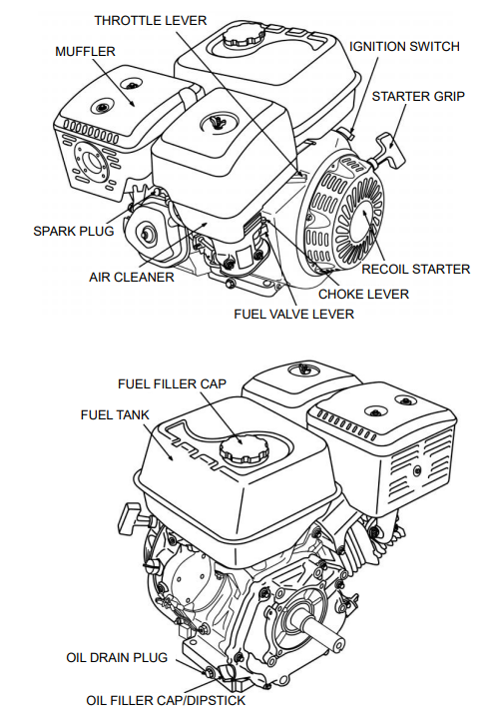
The fuel valve lever must be in the ON position for the engine to run. When the engine is not in use, leave the fuel valve lever in the OFF position to prevent carburettor flooding and to reduce the possibility of fuel leakage.
The throttle lever controls engine THROTTLE LEVER speed. Moving the throttle lever in the directions shown makes the engine run faster or slower.
The engine switch enables and disables the ignition system. The engine switch must be in the ON position for the engine to run. Turning the engine switch to the OFF position stops the engine.
The choke lever opens and closes the choke valve in the carburettor. The CLOSE position enriches the fuel mixture for starting a cold engine. The OPEN position provides the correct fuel mixture for operation after starting, and for restarting a warm engine.
Pulling the starter grip operates the recoil starter to crank the engine.
Warning:
Improperly maintaining this engine, or failing to correct a problem before operation, could cause a malfunction in which you could be seriously injured. Always perform a pre-operation inspection before each operation, and correct any problem.
Before beginning your pre-operation checks, be sure the engine is level and the engine switch is in the OFF position.
Check the General Condition of the Engine - Look around and underneath the engine for signs of oil or petrol leaks.
Remove any excessive dirt or debris, especially around the muffler and recoil starter.
Look for signs of damage - Check that all shields and covers are in place, and all nuts, bolts, and screws are tightened.
Check the Engine - Check the engine oil level. Running the engine with a low oil level can cause engine damage. The Oil Alert system (applicable engine types) will automatically stop the engine before the oil level falls below safe limits. However, to avoid the inconvenience of an unexpected shutdown, always check the engine oil level before start-up. Check the air filter. A dirty air filter will restrict air flow to the carburettor, reducing engine performance. Check the fuel level. Starting with a full tank will help to eliminate or reduce operating interruptions for re-fueling.
STARTING THE ENGINE
- Ensure split control lever is in neutral (N) position.
- Move the fuel valve lever to the ON position.
- To start a cold engine, move the choke lever to the CLOSE position. To restart a warm engine, leave the choke lever in the OPEN position
- Move the throttle lever away from the SLOW position, about 1/3 of the way toward the FAST position
- Operate the starter. RECOIL STARTER (all engine types): Pull the starter grip lightly until you feel resistance, then pull briskly. Return the starter grip gently.
- If the choke lever has been moved to the CLOSE position to start the engine, gradually move it to the OPEN position as the engine warms up.
Warm up the engine without load for about 3 minutes before using.

STOPPING THE ENGINE

To stop the engine in an emergency, simply turn the engine switch to the OFF position. Under normal conditions, use the following procedure.
- Move the throttle lever to the SLOW position.
- Turn the engine switch to the OFF position.
- Turn the fuel valve lever to the OFF position.

SETTING ENGINE SPEED
Position the throttle lever for the desired engine speed.
Operating the splitter at speeds below 50% may cause undesirable splitting performance and cause the engine to stall. We recommend an engine speed of 75%> to provide optimum log splitter performance.

DIESEL LONCIN 440D Variant:
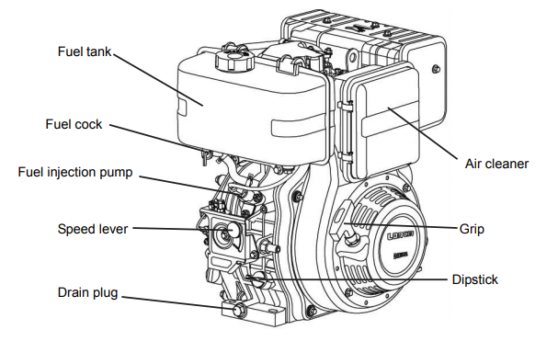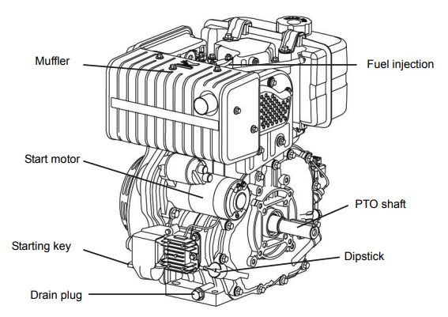
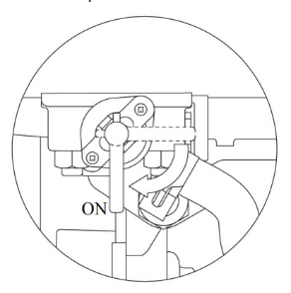
Engine Speed Lever
Fuel Valve Lever
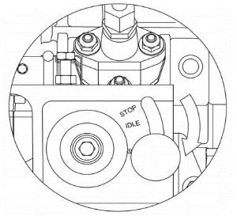
STARTING THE ENGINE (Electric Start)
- Ensure split control lever is in neutral (N) position.
- Move the fuel valve lever to the ON position.
- Set the engine speed lever at START position,
by turning the engine speed control knob to right.
- Turn the starting key to START
- Remove your hand from the key as soon as the
engine starts.
- If the starting motor doesn’t start after 10 seconds, wait a while (for about 15 seconds) before attempting to start again. If the engine is difficult to start in cold weather, press the heater button for about 10-20 seconds and then release before attempting to start.

CAUTION
If the starter motor is turned for too long, the battery will go flat and the motor will seize up. When the engine is stopped, and the starting key switch is turned clockwise to the “ON” position, the oil pressure Indicator light should be illuminated. When the engine is running, and the start switch key is in the “ON” position, the oil pressure indicator light should go out. If the light stays lit, you should stop to check the oil level.

Warm up the engine without load for about 3 minutes.
Turn the engine speed lever to the desired speed position, and fasten the thumb nut to lock the position.

STOPPING THE ENGINE
To stop the engine in an emergency, simply turn the engine speed control knob to the OFF position. Under normal conditions, use the following procedure:
- Move the engine speed lever to low speed, and run the engine for about 3 minutes with no load.
- Turn the engine speed control knob to the left, return the engine speed lever to the STOP position.
- Return the starter key to the “OFF” position
- Set the fuel cock lever to “OFF” (closed) position
- Pull the recoil starter slowly, stop when it feels tight. This closes the intake and exhaust valves (in compression position) and helps prevent rust from forming.

Warning:
Improperly maintaining this engine, or failing to correct a problem before operation, could cause a malfunction in which you could be seriously injured. Always perform a pre-operation inspection before each operation, and correct any problem.
Before beginning your pre-operation checks, be sure the engine is level and the key is in the OFF position.
Check the General Condition of the Engine - Look around and underneath the engine for signs of oil or diesel leaks.
Remove any excessive dirt or debris, especially around the muffler and recoil starter.
Look for signs of damage - Check that all shields and covers are in place, and all nuts, bolts, and screws are tightened.
Check the Engine - Check the engine oil level by removing and inspecting the dipstick. Running the engine with a low oil level can cause engine damage. Check the air filter. A dirty air filter will reduce engine performance. Check the fuel level. Starting with a full tank will help to eliminate or reduce operating interruptions for re-fueling.

ENGINE MAINTENANCE (Petrol or Diesel)
Good maintenance is essential for safe, economical, and trouble-free operation. It will also help reduce air pollution. Please refer to the specific engine manual provided for maintenance intervals and procedures.

SPLITTING OPERATION
Before starting the log splitter, review the following instructions and safety information for safe operation. Failure to follow these rules may result in serious injury to the operator or bystanders from moving parts that could crush, cut, or entangle; from flying objects, fire, falling or tripping, or from carbon monoxide poisoning.
General Safety Information
Read the manual - Do not allow anyone to operate the log splitter who has not read the operators manual, or has not been instructed on the safe use of the splitter. The log splitter owner should instruct all operators in safe log splitter operation.
Age Restrictions – Never allow anyone under 16 years old to operate the log splitter. Children 16 years and older must be trained and supervised by a trained adult.
Intended use – Log splitters should only be used for splitting wood logs, lengthways with the grain. Do not use for other purposes as unforeseen hazards may result.
Modifications – Never modify or alter the log splitter in any way. Modifications can create serious safety hazards and will void the warranty.
Attachments – Never add attachments to the splitter, except for authorized accessories supplied by the manufacturer with instructions for safe installation and use.
Remote Control – Never attach a rope, cable, or other remote device to the splitting control.
Splitting Wedge – Never attempt to change the height or speed of the splitting wedge.
Safety Equipment / Controls – Always operate the splitter with all the safety equipment in place and in good working order, with all controls properly adjusted for safe operation.
Know How to Stop – Be thoroughly familiar with all controls and with the proper use of the equipment. Know how to stop the log splitter and relieve system pressures if needed.
Operating Speed – Always operate the log splitter at the manufacturers recommended speed. Adjust the engine speed so the flow does not exceed the maximum permitted 22GPM. Higher flow rates may make the beam slide move dangerously fast.
Daylight Operation Only – Only use the splitter in daylight so you can see what you are doing.
Smoking / Sparks – Never smoke while operating the log splitter, and never smoke near sources of sparks or flames.
Under the Influence – Never operate, or allow others to operate the log splitter while under the influence of alcohol, drugs or medication.
Unattended – Never leave the machine unattended with the engine running.
Adjusting / Repairing – Turn the engine off and relieve residual system pressure before cleaning, repairing or adjusting the log splitter.
Replace Labels – Always ensure safety labels are in place and in good legible condition.

Protective Clothing / Gear - Wear the following personal protective equipment:
Eye protection - Always wear safety glasses or goggles when operating the machine. Pieces of log may fly out and serious eye injury may occur.
Boots – Falling logs can crush feet. Always wear safety shoes or boots when operating or helping to load logs.
Gloves – Wear snug fitting gloves without drawstrings or loose cuffs.
Hearing Protection – The use of ear plugs or ear defenders is recommended.
Loose Clothing – Loose or dangling clothing can become entangled in moving parts. Never wear jewellery or loose-fitting clothing.

Securely Footing/Parking the Log Splitter for Use
The log splitter has two support legs, which are stowed under the main frame. Each leg has two sets of securing holes which the securing pins can locate – One set for ‘stowed’ position, one set for ‘parked’ position. The log splitter should only be used when both legs are engaged in their vertical positions with both foot plates flat, on firm, level, secure land. It is not recommended that the splitter be footed on loose ground as this will make engaging the legs difficult. Failure to engage the support legs may allow the splitter to move or roll away dangerously during operation.
To engage the legs, remove the securing lynch pins, and lower the legs towards the ground until the edge of the footplates contact the ground. Pushing the log splitter firmly backwards will ‘engage’ the legs so the foot plates become flat to the ground. Replace the pins into their respective holes to secure the legs in position.

Setting Horizontal / Vertical Splitting Positions
The horizontal splitting position is used for lighter logs that can be easily loaded onto the beam.
The vertical splitting position is used for light logs as well as heavy logs that are difficult to load onto the beam.
Note – Musculoskeletal injury can result from lifting logs onto the log splitter if proper lifting techniques are not used, or the logs are too heavy for a persons size, weight or strength. In some cases, logs as small as 8” diameter and 14” length may be heavier than what some should be repeatedly lifting onto the splitter.
The use of the vertical splitting position can greatly reduce the need to lift logs onto the splitter. Employers are advised to consider safe lifting guidelines when assigning employees to log splitting tasks.
Warning!
Never change splitting positions with the engine running. You may contact the exhaust and receive serious burns.
Set to Horizontal
Make sure the beam is securely in the horizontal position with the hitch pin.
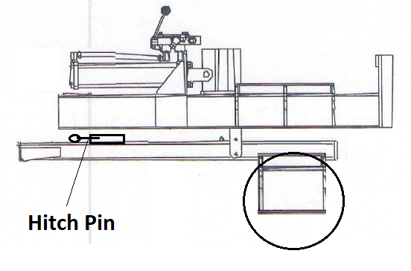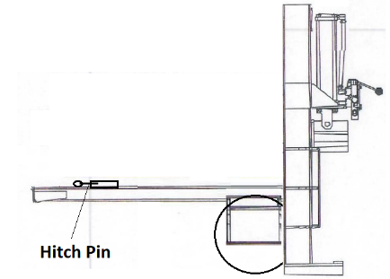
Set to Vertical
Unlock the beam by pulling and holding the spring-loaded hitch pin.
Rotate the main beam/cylinder until beam is vertical, and the end plate is flat on the ground. (NOTE: Beam is very heavy.)

Returning to Horizontal Position
Rotate beam / cylinder down carefully in a controlled manner until beam is horizontal.
Ensure spring loaded hitch pin is securely located into the locking hole.
Warning!
Crush hazard – The beam is heavy – Do not let it just drop. It could cause crush injury and/or cause damage to the splitter.
Loading Log
Load log onto beam with a cut end square against the end plate, positioned for a lengthwise cut, going with the grain of the log.
If the cut end is not ‘square’ against the end plate, excess torsional stresses may occur on the beam causing damage.
The log splitter is designed only for cutting lengthwise with the grain, not for cutting across the grain.
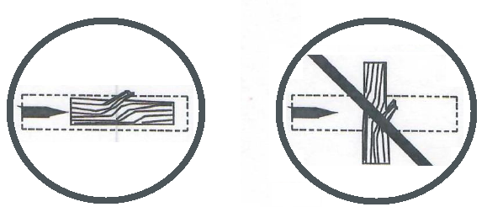
This splitter is designed for cutting logs only up to a maximum of 24” in length, and 16” in diameter cutting with the grain only. Larger diameter logs could get stuck on the wedge, and longer logs will not fit on the beam.

Warning!
Always keep hands and feet away from the endplate, wedge and partially split logs while loading, operating and unloading the splitter.
Important safety instructions:
Hold bark side of logs when loading or positioning, never the ends. Never place your hands or any part of your body between a log and any part of the log splitter.
Note for vertical position loading – Place the log on the endplate and turn it until it leans against the beam and is stable. If the log is too big or oddly shaped, stabilise the log with wooden shims between the log and ground. Do not use your leg or knee to stabilise the log. Never stabilize by placing your hand on the top of the log.
Never load or unload logs while the wedge is moving.
Never straddle, reach across, or step over the beam while the engine is running. You could trip, actuate the controls and get seriously injured.
Do not pile logs to be split in a place that will make you reach across the log splitter in order to load them.
Logs that are not cut square can slide out while splitting and become a safety hazard, or cause excess force to log splitter components. Use a chainsaw to cut logs square on each end before attempting to split them.
Never attempt to split more than one log at a time. Pieces of log can unexpectedly be thrown from the machine causing serious injury or damage.
Do not use the log splitter to split logs against the grain. Doing so may damage the log splitter and could cause pieces of log to be thrown, injuring the operator and bystanders.
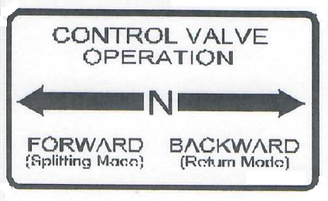
Move the Split Control Lever towards the endplate to extend the ram and split the log.
Important Safety Instructions:
Always operate the log splitter from the indicated operator position as shown in the diagram below. Other positions are unsafe because they increase the risk of injury from crushing, cutting, flying objects or burns.
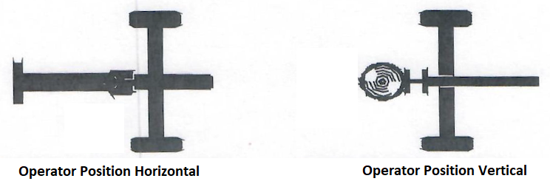

Remove both hands from the log before activating the split control lever.
Une only your hands to operate the split control levers. Never use any other body part, or a rope, cable or other remote device to actuate the unit.
The split control levers feature a safety design where both levers are required to be actuated in the same direction simultaneously using both hands in order to operate the valve. Never modify or remove any part of this safety feature.
Remove both hands from log before activating the split control lever.
Many accidents occur when there is more than one person involved in loading and operating the splitter. Only one person should operate the controls. If a second person is assisting with loading logs, the operator must never actuate the split control lever until the assistant and all bystanders are at least 10ft away. Never allow an assistant to hold the log in place while the operator actuates the split control lever.
Warning!
Cracks in logs can close quickly and pinch fingers. Keep fingers away from any cracks that open in partially split logs.
Stuck Log Procedure
If a log does not split completely and becomes stuck in the wedge, follow the instructions below:
A log can become stuck to the wedge if the wedge becomes embedded in the log and the log doesn’t split and separate. This can happen if the log is too stringy or tough to split completely. A stuck log will move back with the wedge on the initial attempt to retract the wedge. If this happens, stop retracting the wedge immediately and follow the directions below:
Warning!
Never attempt to remove a stuck log by using the hydraulic force of the splitter, by modifying the splitter, or by adding any attachments to the splitter.
Personal injury could result form log or metal pieces flying out at high speed toward the operator or bystanders, or the splitter could become damaged.
- If there is already 1” or more of clearance between the log and endplate, go to step 2, otherwise retract the wedge just enough to remove pressure between the log and the endplate – about 1” clearance (Move the split control lever to ‘Return’, then to ‘Neutral’/N.
- Turn engine off
- Remove stuck log from the wedge manually with a pry bar or sledgehammer
Important – Be extremely careful as log pieces my fly off as they separate from the wedge. Make sure bystanders are clear, and wear safety goggles.
- Do not attempt to re-split a stuck log once it has been removed from the wedge. Manually split with an axe, or cut with a chainsaw.

Move the split control lever away from the endplate to return the wedge (Backward / Return Mode).
Once the valve is actuated in the return direction, the wedge is designed to keep returning by itself completely, then stop automatically. You will notice the lever ‘kick’ itself into the neutral (N) position once the wedge has fully returned.
Warning!
Stay clear while the wedge is returning. It is still powerful enough on the return stroke to cause serious injury.
Move each log away from the log splitter after it is split. Split logs near the log splitter are a trip hazard.
After use, if in the vertical position, return the log splitter to the horizontal position for greater stability, and prepare for transportation.
Storage
Follow the instructions below for storing your log splitter between uses:
Retract the wedge to keep the chrome rod protected from corrosion.
Wipe the beam and wedge with oil to prevent corrosion.
Store the splitter in a dry location away from corrosive material such as fertilizer or similar corrosive materials.

