Please fill in the following in order for us to fabricate the bracket to suit your Mini Digger.
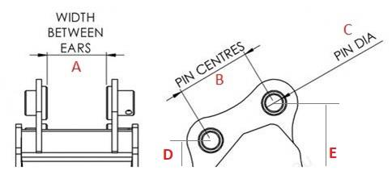
Customer name
Digger type
Does the digger have a quick hitch?
A
B
C
D
E
Notes +
Other parts required

Please email this form back to us.

Kind regards

MDL

